STEM Enrichment Activity Chart
Grades 3-5
Week of May 11 – May 14, 2020
Create  Monday |  | Science  Tuesday |  |  | Coding/Active  Wednesday |  |  | Engineering  Thursday
Try making a flextangle! It’s a paper ring that you can twirl and turn inside out! https://youtu.be/pta1R7g05Xg  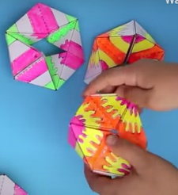  Fine Motor Skills |  | Check-in on the pandas at Zoo Atlanta using the panda-cam! Pick a behavior and count how many times they do that within 10 minutes. https://zooatlanta.org/panda-cam/  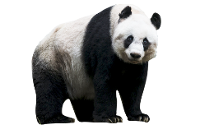  Observation  Animal Features |  |  | Do curl ups and push-ups during commercials when you watch TV  Movement |  |  | Make a paper plate marble run  Find more ideas here: https://babbledabbledo.com/how-to-choose-or-make-a-marble-run-your-kids-will-love/  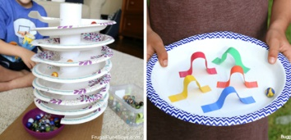  Engineering Design Challenge
Practice gratitude today. Draw a big sun and on the point of each ray, write something that makes you happy!  Social Emotional Learning |  | Build a juicy stomp rocket!  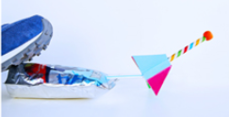  https://babbledabbledo.com/juicy-diy-stomp-rockets/  Forces and Motion |  |  | Try a free coding game at Code for Life!  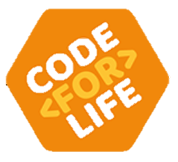  https://www.codeforlife.education/home-learning  Coding |  |  | Try constructing a balance toy like the ones featured here https://babbledabbledo.com  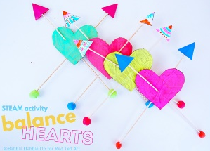  /steam-valentines-day-activity-balance-hearts/  Engineering Design Challenge
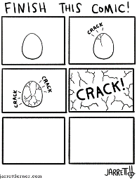  Try out one of Jarrett Lerner’s “Finish this Comic” activities. They are free to print from his website.  https://jarrettlerner.com/activities/  Creative Thinking |  | Play the recycle sort game at https://www.turtlediary.com/game/recycling-waste.html  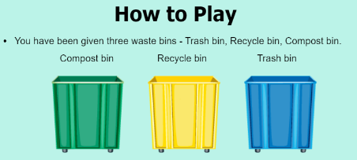  Recycling and Conservation |  |  | Feeling strong emotions? Practice belly breathing. Lay on your back and put your hands on your stomach. Breathe in (counting to 5) and out (counting to five) and make your hands go up and down with your breath. Do this 5-10 times. How do you feel?  Mindfulness  Social Emotional Learning |  |  | With parent permission, use different household items and design a fort or bridge.  Engineering Design Challenge

