STEM Enrichment Activity Chart
Grades K-2
Week of May 4 – May 7, 2020
Create  Monday |  | Science  Tuesday |  |  | Coding/Active  Wednesday |  |  | Engineering  Thursday
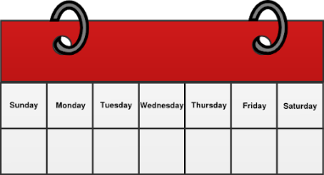  Work with your parents to create a kindness calendar for the week. Do one thing each day that shows kindness to someone in your family!  Kindness Calendar  Social Emotional |  | Pour some water into a small clear glass. Add some oil into the cup and observe what happens. Talk to your parents about why the oil and water are acting the way they do!  Properties of Matter |  |  | Test your reflexes! Have a friend drop an item and try to catch it before it hits the ground.  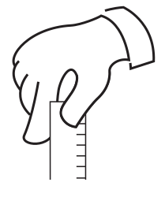  Reflexes and Fine Motor Skills |  |  | Create a cup and string phone by poking the ends of a string through the bottoms of two cups. Try a few different types of cups and string. Which ones work the best? Send a positive message to a family member through your phone.  Engineering Design Challenge
Get out your play-doh or make some using THIS recipe! Use your dough to make faces that show how you’ve been feeling.  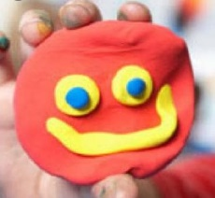  Fine Motor Skills and Social Emotional |  | 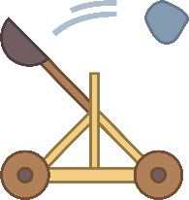  Design and build a catapult with household items to knock over a tower of cups.  Pushes and Pulls |  |  | Make your own directional arrows and code a path outside! Be sure to add moves! (ex: move 3 spaces to the left and pick a flower).  Unplugged Coding |  |  | Using a plastic bag and a cup, build a parachute for a small toy!  Engineering Design Challenge
Use shaving cream and food color to create puffy paint and paint the perfect spring day!  Fine Arts |  | Create a rainbow using a glass of water, sunlight, and a piece of paper!  The Nature of Light |  |  | Design your dream room in Minecraft!  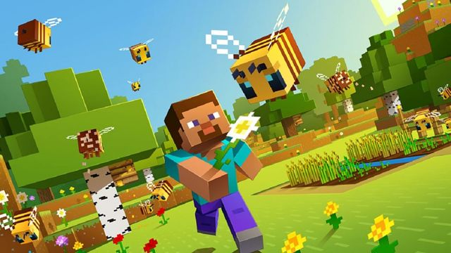  Coding |  |  | Have a paper airplane flying contest with your family! Visit this website for ideas about different shapes and designs. Chart your results!  https://www.foldnfly.com/#/1-1-1-1-1-1-1-1-2  Aerospace and  Fine Motor Skills

