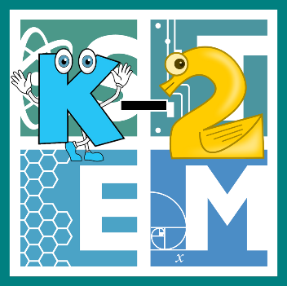 | STEM COBB:  Building like Beautiful Butterflies  2nd Grade STEM Resource from Cobb County Schools  Lesson 5
It's another beautiful week for digital learning! Young learners typically spend some time in the spring learning about life cycles. Students are specifically asked to determine the sequence of the life cycle of insects, such as butterflies (S2L1.a)! This week let's dive into the butterfly life cycle and learn how it's similar and different from other life cycles we know. We are also going to measure to determine how much longer one object is than another (MGSE2.MD.4) when we dig into our STEM challenge for this week.

Materials
empty toilet paper roll empty paper towel roll paper coloring supplies
**building materials you can find around your house- this will look different for everyone. Don't stress it- just use what you have and have fun building

Digital Resources
- Book – The Amazing Life Cycles of Butterflies - https://youtu.be/CwEtD8K_yIQ
- Online Game – Butterfly Life Cycle - http://www.sheppardsoftware.com/scienceforkids/life_cycle/butterfly_lifecycle.htm

Instructions
- Let’s start by learning about the life cycle of butterflies with the book The Amazing Life Cycle of Butterflies by Kay Barnham. https://youtu.be/CwEtD8K_yIQ

- Now that you've learned the steps from a book, let's practice putting them in order. Use this online game to help you review and make sure you totally understand the life cycle. Click on the picture to go to the game. (Parents: Game requires Adobe Flash Player) http://www.sheppardsoftware.com/scienceforkids/life_cycle/butterfly_lifecycle.htm

- As you've learned, butterflies go through a pupa or chrysalis stage where they create a hanging cocoon and undergo a complete metamorphosis! This stage is very important and butterflies will often hang their chrysalis on a branch or under a leaf so that once they come out as a beautiful butterfly, they can hang and use gravity to help stretch out and dry their new wings!

- Today for your STEM challenge, you are going to try and do what butterflies do! Find an empty toilet paper or paper towel roll in your house and use it to represent your cocoon.
  - Ask yourself the question, can I build a structure for hanging this cocoon high enough to allow a butterfly to emerge and dry their wings? Have fun with this project! Make a paper butterfly and hide it inside the empty roll. Make the butterfly just shorter than the roll using your measuring skills- butterflies don't leave much empty space for themselves!
  - Brainstorm ideas for hanging your cocoon.
  - Find materials around your house to hang your cocoon and create your structure.
  - Evaluate your design by trying to pull out your butterfly. Did he have enough room to escape?
  - Do you need to improve your design? Have a blast engineering like a butterfly!

