STEM Enrichment Activity Chart
Grades 3-5
Week of April 20-24, 2020
Create  Monday | Science  Tuesday |  | Coding/Active  Wednesday | Engineering  Thursday |  | Fun  Friday
Write a silly song about something that makes you happy. Sing your happy/ silly song for a family member in person or virtually.  Social Emotional | Explore parts of a cell using bubbles. Made a working model of a cell membrane www.exploratorium .edu/ snacks/cellular-soap-opera  Parts of a Cell |  | Play some basketball or “Trash Can Ball”. See how many baskets you can make out of 10. Write your score as a fraction.  Fractions | Read this story and  then draw your own  robot creation.  bit.ly/robotstory7  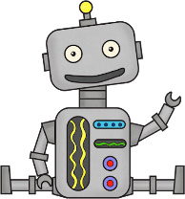  Describe its features and capabilities.  Engineering Design Challenge |  | Use recycled materials at home to create a 3D prototype of your Robot invention.  Engineering Design Challenge
Check out the projects  at scratch.mit.edu  then create your own  game!  Coding & Game Design | Research the importance of bees and other pollinators to ecosystems and foods we eat. https://tinyurl.com/beepol  Write down everything you ate yesterday. Identify the items you wouldn’t have if there were no pollinators.  Animals |  |  | Create a zip line for a small action figure to travel down from at least your shoulder height.  Engineering Design Challenge |  | Create a hoop glider  using a straw and  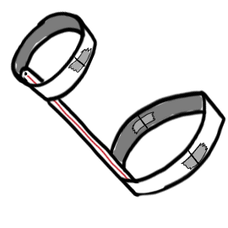  paper. How far can  you make it go?  Aerospace
Make a greeting card  using 3D pop up art for a friend, relative or neighbor.  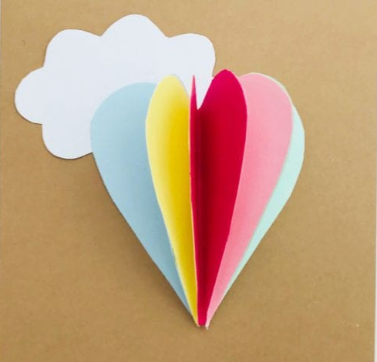  Arts  Enhanced  STEM | Can leaves sweat? Find a leaf on a plant, wrap it in a plastic bag and secure it with a rubber band. Sketch your leaf and bag. After a few hours go back and check your leaf. Record your observations. What do you think is happening?  Plants & Water Cycle |  | Play a coding game at Hour of Code https://hourofcode. com/us/learn  Coding | Save your snacks! Using paper, tape, and string, design, build, and test a device that warns you when someone opens the  kitchen cabinet.  Engineering Design Challenge |  | Can the computer  guess your drawing?  quickdraw.withgoogle.  com  Technology

