STEM Enrichment Activity Chart
Grades 3-5
Week of May 4 – May 7, 2020
Create  Monday |  | Science  Tuesday |  |  | Coding/Active  Wednesday |  |  | Engineering  Thursday
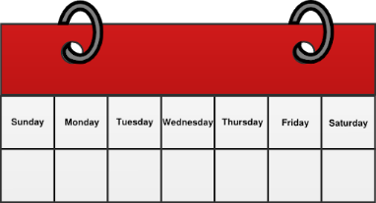  Work with your parents to create a kindness calendar for the week. Do one thing each day that shows kindness to someone in your family!  Kindness Calendar  Social Emotional |  | Create a rainbow using a glass of water, sunlight, and a piece of paper!  The Nature of Light |  |  | Make your own directional arrows and code a new Dance! Be sure to add moves! (ex: move 3 spaces to the left and Dab).  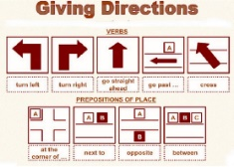  This Photo by Unknown Author is licensed under CC BY-SA-NC  Movement & Coding |  |  | Create a cup and string phone by poking the ends of a string through the bottoms of two cups. Try a few different types of cups and string. Which ones work the best? Send a positive message to a family member through your phone.  Engineering Design Challenge
Pick a project from Origami Way! This site includes many tutorials and step-by-step instructions with pictures for making creative origami works of art!  https://www.origamiway.com/  Art and Fine Motor Skills |  | 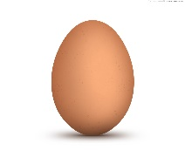  Dissolve an eggshell in vinegar! Take an egg and place it in a cup, pour vinegar over the egg until it is covered. Record how long it takes to dissolve the eggshell. How does the egg feel after the shell is gone!  Chemical Change |  |  | Play Band-Aid tag! All players can tag and be tagged. Once a person is tagged, he or she must put one hand on the spot they were touched to make a Band-Aid. Tagged again? Make a Band-Aid with the other hand. The 3rd time, must visit the “hospital” and complete ten jumping jacks to heal and rejoin.  Movement |  |  | Using a balloon, tape, and straw create a balloon launcher for a toy car!  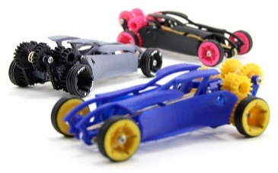  Engineering Design Challenge
Have a paper airplane flying contest with your family! Visit this website for ideas about different shapes and designs. Chart your results!  https://www.foldnfly.com/#/1-1-1-1-1-1-1-1-2  Aerospace and  Fine Motor Skills |  | Have an ice melting battle with your family! Give everyone a piece of ice and see who can get theirs to melt the fastest! Compare strategies and try it a 2nd time.  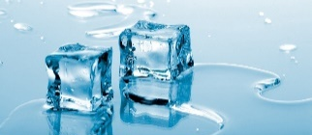  Properties of Matter |  |  | Design your dream room in Minecraft!  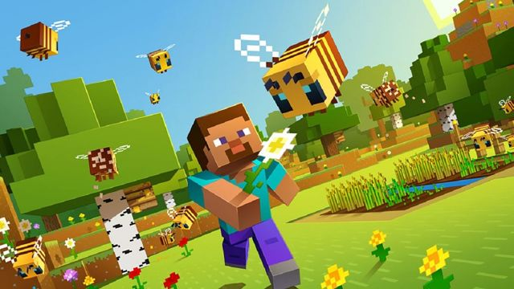  Coding |  |  | Using a plastic bag and a cup, build a parachute for a small toy!  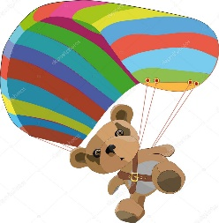  Engineering Design Challenge

