STEM Enrichment Activity Chart
Grades 3-5
Week of May 18 – May 20, 2020
Create  Monday |  |  | Science  Tuesday |  |  | Coding/Active  Wednesday
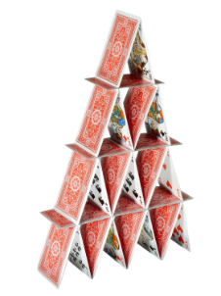  Build a house of playing cards! Can you find another similarly sized material that you can build with using only balance?  Fine Motor Skills |  |  | 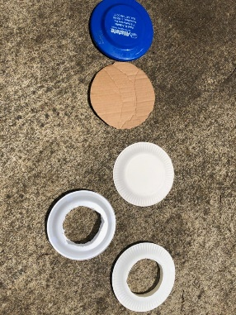  Can you make a homemade frisbee? Try different materials and see which ones fly the best!  Forces and Motion |  |  | Try the Botlogic Game here!  https://botlogic.us/#sthash. v8ew9cM5.w8xFT90N.dpbs  Coding
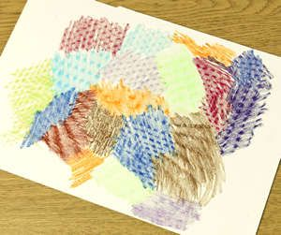  Go on a texture hunt! Lay paper over an object and rub it with the side of a crayon. Can you find 10 different textures in your house?  Fine Arts and Sensory Play |  |  | Try charging a balloon by rubbing it on dry hair, cloth, or some carpet! Then try these static activities! Put the charged part of the balloon near a slow stream of water from the faucet. Put the charged part of the balloon near a few shreds of paper. Put the charged part of the balloon near a small pile of gelatin powder. Put the charged part of the balloon near a bubble that you've caught on a bubble wand!  Static Electricity |  |  | Practice bowling and rolling with homemade pins and a ball! Find something like water bottles that you can use as bowling pins and see if you can bowl a strike!  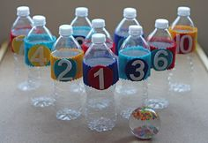  Movement and Engineering
Try one of these digital jigsaw puzzles! Can you create something beautiful from all those pieces?  https://www.jigsawexplorer.com/  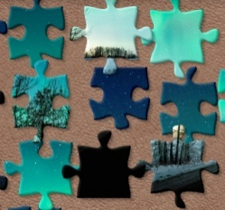  Visual Spatial Learning |  |  | Check out Field Trip Friday at the Georgia Aquarium to learn what Whale Sharks eat!  https://youtu.be/2vpKRypyYd0  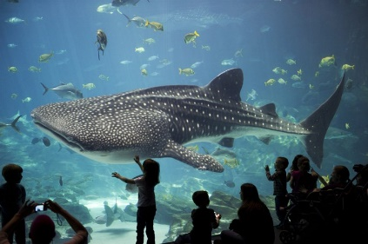  Ecosystems |  |  | Draw a maze in your driveway with sidewalk chalk. Practice going through the maze in different ways (walking, hopping on one foot, backwards, bear crawling, etc.)  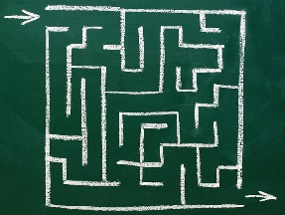  Movement and Critical Thinking Skills

