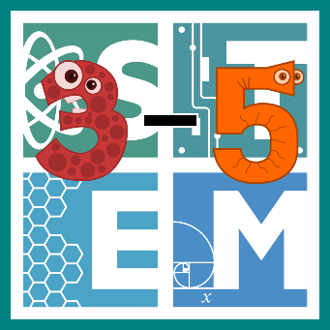 | STEM COBB:  Electrifying Circuits  Fifth Grade STEM Resource from Cobb County Schools  Lesson 4
It's STEM Challenge time! This week we are taking on the study of circuits and electricity! Students in older grades are asked to design a complete simple circuit and explain the necessary components (S5P2.b). For this week's challenge, students will also be asked to exercise their math skills by identifying acute, right, and obtuse angles that exist in their circuits (MGSE4.G.1).

Materials
paper pencil computer
Digital Resources
- Introductory Song – Flocabulary Current Electricity - http://www.stemcobb.com/3-5-blog/electrifying-circuits
- Online Circuit Builder – Phet Sims - https://phet.colorado.edu/sims/html/circuit-construction-kit-dc/latest/circuit-construction-kit-dc_en.html

Instructions
- This week, we are going to start with an amazing song that explains the basics of current (or moving) electricity. Watch it once to enjoy the animation and beat, watch it again to be sure you understand what the words are teaching you! This session will stay active until May 23rd. http://www.stemcobb.com/3-5-blog/electrifying-circuits

- Let's jump into it! This week's challenge is going to look a little different. You are going to open a digital circuit builder and then scroll down for your specific challenges- you will have to click back and forth between this screen and your circuit builder screen. This circuit builder has a built-in tutorial if you're not sure how to use it! https://phet.colorado.edu/sims/html/circuit-construction-kit-dc/latest/circuit-construction-kit-dc_en.html

- Now that you've found the circuit builder, here are your challenges for this week!
CHALLENGE 1: Light the light bulb
You may use: ONE light bulb, ONE battery, and ONE wire. I promise it's possible!
Math connection: Can you identify ONE acute angle in your circuit?
CHALLENGE 2: Light the light bulb
You may use: ONE light bulb, ONE battery, and TWO wires
Math connection: Give your circuit ONE right angle.
CHALLENGE 3: Light the bulb with a switch
You may use: ONE light bulb, ONE battery, THREE wires, and ONE switch.
Math connection: How many angles can you find and record?

- Here’s your official STEM challenge for this week! Can you use the digital circuit builder to complete it?
  - Ask yourself, can I construct a testing station to see if common items will allow electricity to pass through them? We call materials that allow electricity to flow CONDUCTORS. We call materials that stop electricity INSULATORS. Use the down arrows on your tool bar to get to some materials for testing. You should see things like a dollar bill, eraser, a coin, and more!
  - Brainstorm a way to see if these items will allow electricity to pass through them.
  - Create a circuit with a gap for testing! Try out some different things to see if they are conductors or insulators. Record your results!
  - Evaluate your design- could you tell which items were conductors and which were insulators?
  - Improve your design if you need to!

- Looking for a few possible solutions? Visit this site and scroll to the bottom of the post to see a few answers. Keep in mind that yours can look different and still be right! http://www.stemcobb.com/3-5-blog/electrifying-circuits

