STEM Enrichment Activity Chart
Grades K-2
Week of April 20-24, 2020
Create  Monday | Science  Tuesday |  | Coding/Active  Wednesday | Engineering  Thursday |  | Fun  Friday
Using snacks at snack time, create a replica of yourself or of how you are feeling today!  Social Emotional | How many drops of water can fit on a penny? You will need a penny, water, and you can use a medicine dropper or finger to add the water!  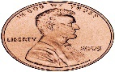  This Photo by Unknown Author is licensed under CC BY-SA  Properties of Matter |  | Make your own directional arrows and code a new Dance! Be sure to add moves! (ex: move 3 spaces to the left and Dab).  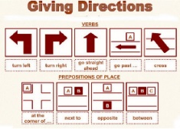  This Photo by Unknown Author is licensed under CC BY-SA-NC  Movement & Coding | 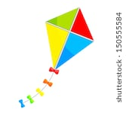  Using paper, straws, tape and string make your own kite!  Engineering Design Challenge |  | Playdough Maze!!  Use a flat baking sheet, playdough, and a marble to create a maze!  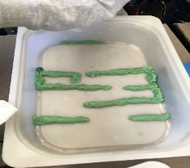  This Photo by Unknown Author is licensed under CC BY-SA-NC  Engineering Design Challenge
Create an animal or place with tangrams!  https://www.abcya. com/games/tangrams  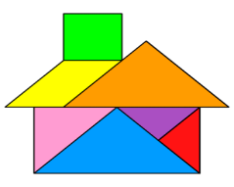  Technology & Social Emotional | With permission, make a drum set out of pots and containers. Examine the sound that each item makes when struck by a wooden spoon, metal spoon, and plastic spoon. Describe the pitch as high/low or soft/loud.  Sound |  | 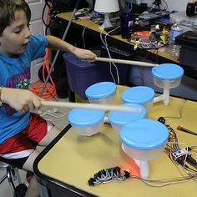 | With parent permission, use different household items and design a fort or bridge.  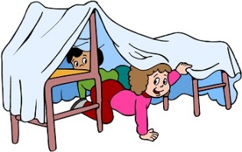  Engineering Design Challenge |  | Create a game for your family! Add different questions that your family members would have to answer!  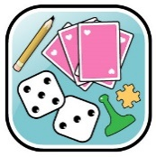  Game Design
Draw a picture and cut it like a puzzle to have someone put it together!  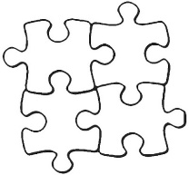  This Photo by Unknown Author is licensed under CC BY-NC-ND  Arts Enhanced Creativity | Make your own bubble solution. Design a wand with your hand or other household items!  Properties of Matter |  | Code a map that helps families navigate through the house!  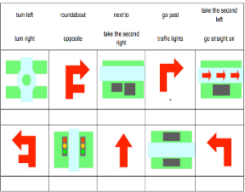  This Photo by Unknown Author is licensed under CC BY-SA-NC  Coding | Design your street, neighborhood or school in Minecraft!  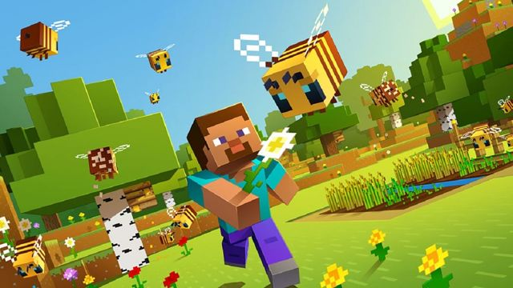  Engineering Design Challenge |  | 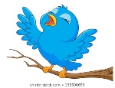  Create your own bird feeder! Use a string cereal on a loop and hang or spread either honey or peanut butter on a pinecone and cover with cereal. Hang it outside for the birds to  nibble!  Design Challenge

