STEM Enrichment Activity Chart
Grades K-2
Week of May 11 – May 14, 2020
Create  Monday |  | Science  Tuesday |  |  | Coding/Active  Wednesday |  |  | Engineering  Thursday
Practice mindful coloring! Set the tone with some calming music. Color or doodle quietly as you breathe in and out. Note that you can use any coloring pages or books on hand, or grab these free printable mindful coloring pages to start.  Mindfulness  Social Emotional Learning |  | 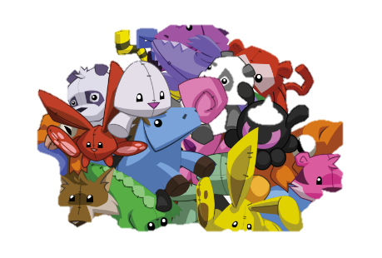  Sort your stuffed animals (or hot wheels cars, dolls…) by color. Can you sort them another way? (size, type)  Identifying Characteristics |  |  | 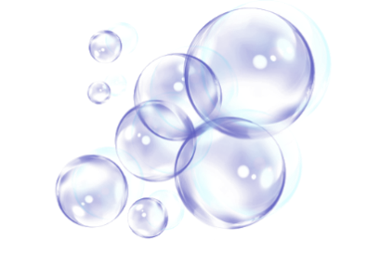  Go outside and blow some bubbles. Pretend that there are bubble flies everywhere! Use your fly swatter to get rid of them as quickly as you can.  Coordination  Gross Motor Skills |  |  | Make a paper plate marble run  Find more ideas here: https://babbledabbledo.com/how-to-choose-or-make-a-marble-run-your-kids-will-love/  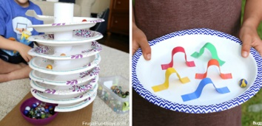  Engineering Design Challenge
Try making a flextangle! It’s a paper ring that you can twirl and turn inside out! https://youtu.be/pta1R7g05Xg  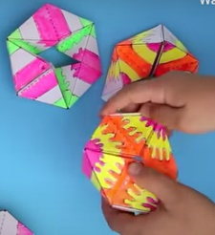  Fine Motor Skills |  | Do some shadow drawings! In the morning (8am) or later afternoon (4pm) use sidewalk chalk to trace a shadow of either a person or familiar object. Come back several hours later and place the object in the same place. Does the shadow match your original outline?  Patterns of the Sun |  |  | 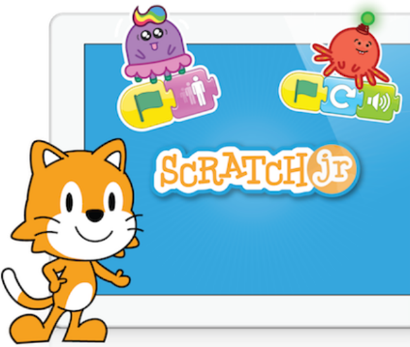  Download and play on the Scratch Jr. app!  Coding |  |  | Make a paper helicopter. Try different sizes and materials to see which ones fly the best!  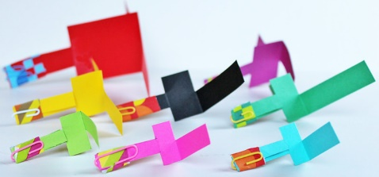  Engineering Design Challenge
Play “Sound Search.” Everyone sits still and silent for one minute. Then, identify as many different sounds as possible.  Mindfulness  Careful Observation |  | Check-in on the pandas at Zoo Atlanta using the panda-cam! Pick a behavior and count how many times they do that within 10 minutes. https://zooatlanta.org/panda-cam/  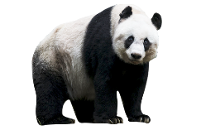  Observation  Animal Characteristics |  |  | Gather all of your small stuffed animals for a carnival-style game of ring toss! Cut out the center of a few paper plates, forming a ring. You can decorate them! Set up your stuffed animals in a clear area and toss the rings trying to get them to land over the stuffed animals.  Coordination & Movement |  |  | 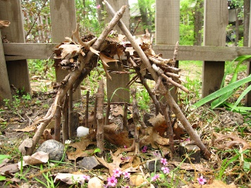  Natural materials challenge – Can you collect sticks, twigs, and building materials to build a structure outside?  Engineering Design Challenge

