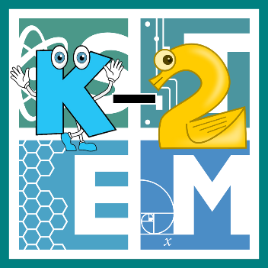 | STEM COBB:  The Plants on Planet Greenhouse  1st Grade STEM Resource from Cobb County Schools  Lesson 6
Welcome back young ones and parents! At this time of year, primary students are learning to obtain, evaluate, and communicate information about the basic needs of plants (S1L1). This week, we are going to be creating a brand new plant with those needs in mind! We are also going to use some non-standard units to measure our plant using materials we have in our homes (MGSE1.MD.2). We are also going to share our work with an adult and tell them why we made the art choices that led to our new plant (VA1.RE.1). Let's get started!

Materials
Any arts/crafts materials you have around your home
A small amount of a toy with a standard size (Legos, crayons, wood blocks, etc.)

Digital Resources
- Book – A Seed in Need - https://youtu.be/lxYazAokfDQ
- Online Game – How Plants Grow - https://www.sciencekids.co.nz/gamesactivities/plantsgrow.html

Instructions
- Do you already know what a plant needs to survive? Double check your thinking by reading (or listening to) this great book! It’s called A Seed in Need by Sam Godwin. https://youtu.be/lxYazAokfDQ

- Think you've got it figured out? Try out what you know using this online game! You will be clicking the water and heat levers to keep the plant happy and growing! (Parents: Requires Adobe Flash Player) https://www.sciencekids.co.nz/gamesactivities/plantsgrow.html

- Now that you're an expert on the 4 main things that plants need to grow (air, water, light, and nutrients) you are going to get creative today with our STEAM challenge! In today's challenge, you are going to use what you've got at home to create a plant for the make-believe Planet Greenhouse! Planet Greenhouse is the perfect environment for new plants. There's plenty of air, light, water, and very rich soil, but the plant you design needs to be able to take in those essential things. You'll need a plant with strong roots and leaves, and maybe even some fruit or flowers that it can grow in such a rich environment!
  - Ask yourself the question, "How can I use mixed media to create a 2D or 3D work of art depicting a new plant?"
  - Take a look at the materials you have at home and brainstorm a plan for using them to show a plant with roots, leaves, and either fruit or flowers.
  - Have fun creating a plant with plenty of color and personality! Tell an adult about the artistic choices you made when creating your plant. You could talk about the media, size, proportion, shape, color, texture, etc.
  - Let's evaluate the size of your plant using a new unit. Pick out a group of toys you have at your house that are all the same size. How big is your plant in Legos? What about crayons? How many crayons tall is your plant? Show your parents your work and measure carefully and precisely!
  - Decide if there are any parts of your plant that you'd like to improve or change.
  - Have a blast and feel free to share your designs on twitter and tag @stemcobb so that we can see your designs!

