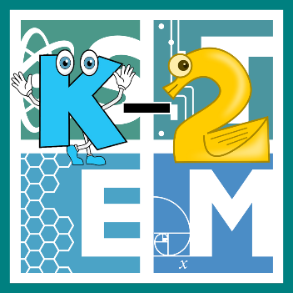 | STEM COBB:  Egg-cellent Inventions  2nd Grade STEM Resource from Cobb County Schools  Lesson 7
Welcome to our final week of digital learning! We are thankful that you've continued to check in and try out these awesome STEM activities at home! This week, we are taking our last look at life cycles by focusing on birds. Young students should be able to determine the sequence of the life cycle of common animals in your area- including birds (S2L1.a)! We are also going to fluently adding and subtracting within 20 using mental strategies (MGSE2.OA.2). Let's get into it!

Materials
eggs cardboard (corrugated works best) toothpicks

Digital Resources
- Book – My Life as a Chicken - https://youtu.be/M5YqokuYqX0
- Online Game – Parrot Life Cycle http://www.sheppardsoftware.com/scienceforkids/ life_cycle/bird_lifecycle.htm

Instructions
- As we've done each week- let's start by learning from a great book! Here's one we like called My Life as a Chicken by Ellen A. Kelley https://youtu.be/M5YqokuYqX0

- Now let's take what we know about chickens and see if we can apply it to another bird's life cycle. Try out this online game to see if you can correctly order the life cycle of a parrot! Click on the picture to open the game (Parents: requires Adobe Flash Player) http://www.sheppardsoftware.com/scienceforkids/ life_cycle/bird_lifecycle.htm

- Finally, let's do some engineering! The most fragile part of a bird's life cycle is certainly the while they are inside an egg. Birds are GREAT at building soft and protective nests to keep their eggs safe. In our home, we normally keep eggs for eating! What if we didn't have the amazing egg cartons that keep our eggs from rolling around and getting broken!
  - Ask yourself, can I build a simple device to keep eggs from rolling using just cardboard and toothpicks? For this challenge, you only get 20 toothpicks and a rectangular piece of cardboard (parents, cardboard should be about the same size as an egg carton).
  - Brainstorm ideas for how to keep your egg from rolling around. Think about how you might keep more than one from moving - how many toothpicks do you need for each egg?
  - Gather your materials and create your design!
  - Evaluate the design by putting a few eggs in and seeing if they stay put.
  - Can you come up with any ways you could improve your design? Could your design be altered to protect more eggs?

Have fun and have an amazing summer! With love, Your STEM Cobb Team!

