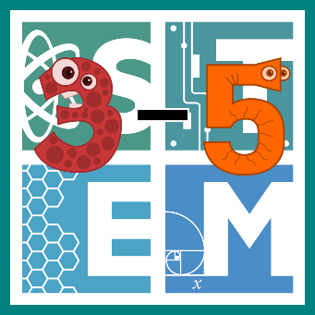 | STEM COBB:  Simple Machines: Lever Launchers  4th Grade STEM Resource from Cobb County Schools  Lesson 5
This week we are diving into the exciting world of simple machines! They are all around us and provide wonderful learning opportunities while we're at home. Students in upper elementary school should be asking questions to identify and explain the uses of simple machines (S4P3.c). Students also convert among different-sized standard measurement units (MGSE5.MD.1).

Materials
paper pencil measuring tool materials for building found around your house
Digital Resources
- Introductory Song – Flocabulary Simple Machines - http://www.stemcobb.com/3-5-blog
- Download App – Inventioneers - https://www.filimundus.com/inventioneers/

Instructions
- This week, we are going to start with an amazing song that explains the basics of simple machines. Watch it once to enjoy the animation and beat, watch it again to be sure you understand what the words are teaching you! This session will stay active until May 30th. http://www.stemcobb.com/3-5-blog

- Next, it's time to try one of the most fun apps EVER for learning about simple machines. Download INVENTIONEERS for free and see if you can build simple machines to accomplish silly tasks! This game does a great job of teaching how the combination of simple machines and gravity can accomplish big things! https://www.filimundus.com/inventioneers/

- Now it's finally time to work on a STEM engineering challenge. There are so many different simple machines challenges out there, but this is the one we liked the best! Today you are going to build a snack delivery launcher! Consider what you know about levers.
  - Ask yourself, "How can I build a lever launcher that could send a snack across the room to a family member?" Consider using snacks like bites of cereal, fruit snacks, or goldfish.
  - Brainstorm ideas for your design. Consider what you have handy at your house to build with. What could you build the lever from? What would make a good fulcrum? How long and high do both of those parts need to be?
  - Once you've settled on a design, create it! Then take a stab at launching some snacks!
  - Evaluate your construction: How far did they travel in inches? How far did they travel in feet? Did it make the snacks go the direction you intended?
  - Take time to improve your design to make it launch more accurately. Have fun!

