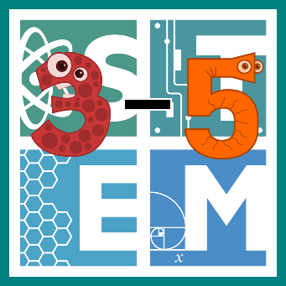 | STEM COBB:  Lever Launchers  4th Grade STEM Resource from Cobb County Schools  Lesson 7
Welcome back to your final week of digital learning! You did it! Here's one last activity to get you to summer. At the end of the year, students learn to ask questions to identify and explain the uses of simple machines (lever, pulley, wedge, inclined plane, wheel and axle, and screw) and how forces are changed when simple machines are used to complete tasks (S4P3.c). We are going to build a simple machine and convert measurements from larger units to smaller units (MGSE4.MD.1).

Materials
Building materials you can find around your home- consider cardboard, craft materials like popsicle sticks, and common desk supplies. Materials needed are dictated by student designs!

Digital Resources
- Introductory Book – Simple Machines: Wheels, Levers, and Pulleys - https://youtu.be/7T9GXwc6jbQ
- Online Interactive and Game – PHET Sims Balancing Act - https://phet.colorado.edu/sims/html/balancing-act/latest/balancing-act_en.html

Instructions
- ​You know what comes first! Let's read and learn! This is the book Simple Machines: Wheels, Levers, and Pulleys by David Adler https://youtu.be/7T9GXwc6jbQ

- Let's try a simulation that lets you see balanced and unbalanced forces! Can you keep things balanced? https://phet.colorado.edu/sims/html/balancing-act/latest/balancing-act_en.html

- Now that you know how to keep forces balanced, we are going to create something to make them UN-balanced! Your challenge this week is a build a catapult that will launch a small item (like a penny or paper clip) as far as possible!
  - Ask yourself, how could a launch a small item across the room using a simple machine?
  - Brainstorm possible ideas! Consider which type of simple machine would make the best catapult and what materials you could use around your house to construct your design.
  - With your parents’ permission, gather materials and create your design.
  - Evaluate your design by trying to use it. Does it work? Could you make it launch farther? Measure the distance that you're able to launch your small item and try converting it to other units. If you measure in meters, how many centimeters did it go? Check your work!
  - Could you do anything to improve your design and launch things further? Have a blast launching items around your house and have an amazing summer!

All our love!
Your STEM Cobb Team

