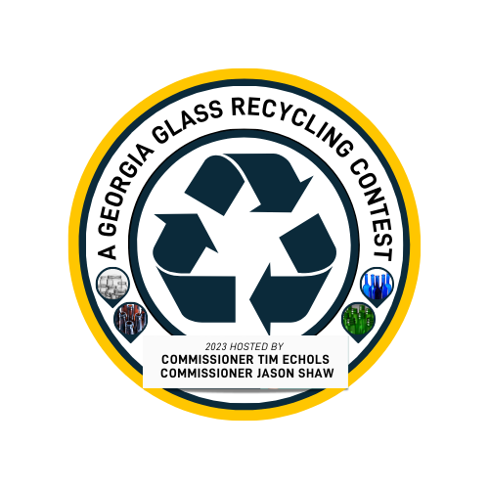

2023-2024 Georgia Glass Recycling Contest
Hosted by GAPSC Commissioners Tim Echols & Jason Shaw
School Participation Agreement

School Name:___________________________________________________________________
Advisor:_______________________________________________________________________
Cell Number:____________________Email:_________________________________________________
Club Participating:_______________________________________________________________
Student Contact:________________________________________________________________
Cell Number:____________________Email:_________________________________________________
Provide an address for mailing and how the check should be made out in the event your school wins a cash prize:_______________________________________________________________
______________________________________________________________________________
By signing this agreement, this school agrees to participate in the 2023-2024 Georgia Glass Recycling Contest and understands that it is their responsibility to abide by the rules outlined below.
- Collect, clean, and sort glass according to best practices for safety and glass quality.
- Arrange with Comm. Echols’ Office for pickup of glass at your school by Monday, April 15th 2024.
- After delivering glass, email your team's idea on what it would take for Georgia high schools to start a glass recycling program to fhenning@psc.ga.gov.
Advisor Signature:_____________________________________________________Date:_____________
Student Signature:_____________________________________________________Date:_____________
Please return via email to fhenning@psc.ga.gov ASAP to participate.

