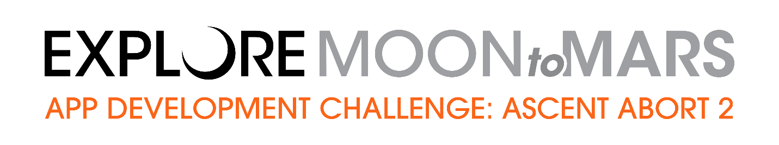NASA’s App Development Challenge (ADC) provides an opportunity for middle and/or high school students to demonstrate the practice of coding and app development. In this ADC, students work in teams to develop an app that visualizes three minutes of simulated test data in support of the upcoming Ascent Abort-2 (AA-2) flight test.

In June 2019, NASA will launch a full-stress test of the Orion spacecraft’s Launch Abort System (LAS), called Ascent Abort-2, which will demonstrate the LAS can send Orion and its crew a safe distance from a failing rocket if an emergency arises during ascent to orbit. This flight test is a critical step to demonstrate Orion’s safety as NASA leads the next steps of human exploration into deep space.

In Round 1 of this challenge, participants will have the opportunity to chat with NASA subject matter experts to learn tips on how to make the app the best it can be. Teams will then post videos of their app designs online for consideration by NASA to use in future missions. In Round 2, teams with favorable submissions advance to present their app in an interview with NASA engineers working on the AA-2 flight test. After this round, NASA will select student team/s for an all-expenses paid trip to a NASA field center in early summer, 2019.

The challenge begins on March 13, 2019 and Round 1 participation concludes with video submissions on May 1, 2019.

Review the Challenge
Student teams must:
- Be able to process approximately three minutes’ worth of data smoothly.
- Use any programming language (e.g. Java, Scratch, etc.) and/or operating systems (Windows, Android, etc.) to complete development of an app.
- Read 21 double-precision floating point numbers (doubles) that represent position and rotation of the rocket’s three main parts from an external source.
- Display all 21 doubles (although not necessarily simultaneously) in some meaningful form beyond text.
- Submit a video of original student led work on the completed app.
- Adhere to you school districts' policies regarding participation in the challenge.
- Complete program requirements as identified by the ADC team.

Review the Timeline
- March 13: Live Virtual Kick-Off Event and Presentation
- March 27: Live Virtual Connection - Game Engine Scripting for Object Motion
- April 3: Live Virtual Connection - Pseudo Coding for Quaternion
- April 10: Last Day to Enter the Challenge
- April 17: Live Virtual Connection - Human Factors for Visualization Application
- May 1: ADC Video Submission Deadline

Form a Team
All participants must be:
- U.S. Citizens
- On a team of five to six middle or high school students and a lead teacher
- At least 13 years of age
- Led by a certified and practicing K-12 educator (i.e., lead teacher)

Notify NASA
After a thorough review of all of the above, email NASA’s ADC team at JSC-M2MSTEM@mail.nasa.gov with questions or with your team’s intent to participate.

Lead teachers must email a notification of intent to participate in the challenge. Notification of intent to participate must be received and confirmed, no later than April 10, 2019. A letter of support from your school administrator must be included.

Get the Guide and Go
A guide to help tackle the ADC will be released on our website on March 13, 2019.

Hurry, the App Development Challenge is scheduled to start March 13, 2019!

For more information and a detailed description of program details please visit:
www.nasa.gov/education/appchallenge

Or email the ADC Team at JSC-M2MSTEM@mail.nasa.gov

