STEM Enrichment Activity Chart
Grades K-2
Week of April 27-April 30, 2020
Create  Monday |  | Science  Tuesday |  |  | Coding/Active  Wednesday |  |  | Engineering  Thursday
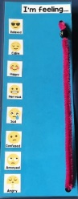  Keep in touch with how you’re feeling during this time. Make feeling scale with some paper, a pipe cleaner, and a bead and share how you’re feeling with a family member each day.  https://tinyurl.com/yamg4fm4  Social Emotional |  | 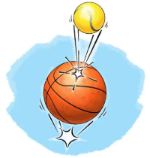  Place a small ball on top of a large ball and drop them together. Watch how energy is transferred!  Forces and Motion |  |  | Go for a walk and play “I Spy” using colors or letters.  Example: I spy something that starts with “T.”  Answer: Tree  Literacy Connections |  |  | Build a house for a toy figurine. Can you make different rooms? How big does the door need to be for them to get inside? What kind of furniture could they use?  Engineering Design Challenge
Fold an origami bunny rabbit bookmark for all the great books you’re reading!  https://tinyurl.com/yyltrunu  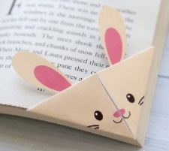  Fine Motor Skills |  | Show your skills at matching animal traits and characteristics with this awesome game!  https://blockly.games/ puzzle?lang=en  Animals |  |  | Play a game on the Think & Learn Code-a-pillar app.  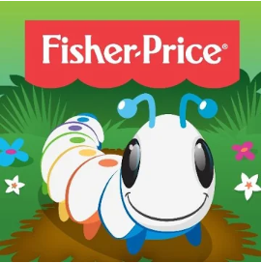 |  |  | Create a boat out of foil that floats in the bathtub. Can it hold a toy without sinking? How many toys or Legos can it hold?  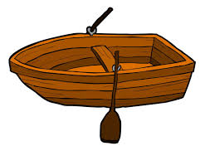  Engineering Design Challenge
Try using Legos to create a self-portrait!  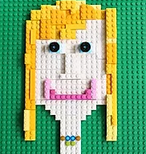  Arts  Enhanced  STEM |  | Sprinkle pepper into a dish of water. Dip one finger into dish soap then touch the surface of the water. What happens?  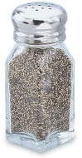  Attributes of Matter |  |  | Check out the projects at scratch.mit.edu then create your own game!  Coding |  |  | 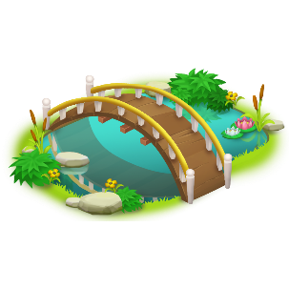  Engineers solve problems to improve our lives! Build a bridge with blocks or other toys you have at home to help your toys cross a small river.  Engineering Design Challenge

