STEM Enrichment Activity Chart
Grades K-2
Week of May 18 – May 20, 2020
Create  Monday |  |  | Science  Tuesday |  |  | Coding/Active  Wednesday
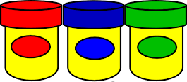  Talk to your parents about setting up a play-doh play date with a friend! Get on a video call and share what you’re making with play doh with a friend! Give each other small challenges like, “Who can build the quickest teacup?”  Sculpture and Sensory Play |  |  | Use this recipe to make GIANT homemade bubbles! There’s a link here for how to make a giant bubble wand as well!  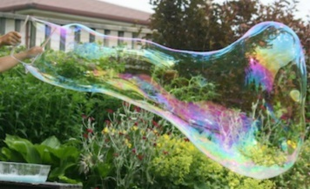  https://happyhooligans.ca/homemade-giant-bubbles/  States of Matter |  |  | Try the Botlogic Game here!  https://botlogic.us/#sthash. v8ew9cM5.w8xFT90N.dpbs  Coding
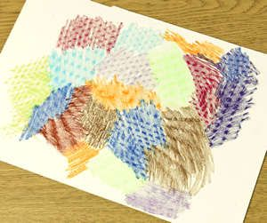  Go on a texture hunt! Lay paper over an object and rub it with the side of a crayon. Can you find 10 different textures in your house?  Fine Arts and Sensory Play |  |  | Make sensory bottles at home! Fill empty water bottles with different mixtures of vegetable oil, water, food coloring, glitter, and small objects like beads or tiny toys. Close the top and have fun tipping it back and forth and watching things move! More inspiration here:  https://youtu.be/76MTGCgFt5E  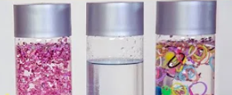  Properties of Matter |  |  | Do you have a large empty box sitting around? Open both ends and use it like a tunnel. Practice crawling through it to get to common places in your house (your room, kitchen, etc.). Take it out on a nice day and pretend it’s a tunnel to an imaginary place!  Gross Motor Skills & Imaginative Play
Try one of these digital jigsaw puzzles! Can you create something beautiful from all those pieces?  https://www.jigsawexplorer.com/  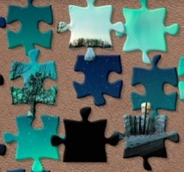  Visual Spatial Learning |  |  | Check out Field Trip Friday at the Georgia Aquarium to learn what Whale Sharks eat!  https://youtu.be/2vpKRypyYd0  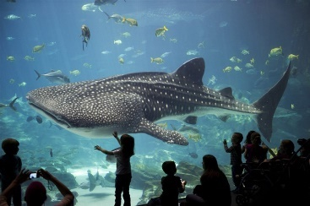  Animal Characteristics |  |  | Draw a maze in your driveway with sidewalk chalk. Practice going through the maze in different ways (walking, hopping on one foot, backwards, bear crawling, etc.)  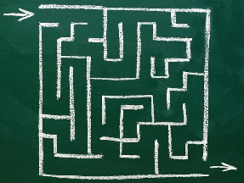  Movement and Critical Thinking Skills

