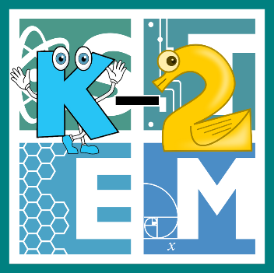 | STEM COBB:  Feathers, Fur, and Scales  Kindergarten STEM Resource from Cobb County Schools  Lesson 4
Welcome back to another great week of Digital Learning! This week we are going to be studying some differences between animals. Encourage your young ones to notice the features of family pets and animals that they can safely observe outside! How could they construct an argument supported by evidence for how animals can be grouped according to their features (SKL2.a)? The challenge this week will also require students to Organize, represent, and interpret data in order to make the best choices for their design! (MGSE1.MD.4)

Materials
paper pencil various materials for building a bird feeder (possibly pine cones, seeds, etc.)
Digital Resources
- Book – Animal Groups - https://youtu.be/VjDUuT1jlyA
- Online Game – Bird Song Hero Game - https://academy.allaboutbirds.org/features/bird-song-hero/bird-song-hero-tutorial
- Recommended app – Merlin Bird ID - https://merlin.allaboutbirds.org/

Instructions
- Here’s a fantastic book to get you started. It’s called Animal Groups by James Bruchac https://youtu.be/VjDUuT1jlyA

- This week, we are going to focus specifically on the bird family. There are a few things birds have in common. They all have 2 feet and wings. They are covered in feathers. They have a beak or bill, and they lay eggs. Did you know that birds can also be very different? One big difference is the sounds that different birds make. Give your child a little screen time to play a game where they learn to identify bird songs using visual shapes! https://academy.allaboutbirds.org/features/bird-song-hero/bird-song-hero-tutorial

- What kind of birds live near your home? Take a few days this week to really pay attention. Pick about 15 minutes a day to go outside and be still and quiet. Mornings are best, but you can try anytime that works for you. Can you hear or see any birds? If you can, try to identify what kind they might be and make a list to track your data! Here's a really helpful app for that. https://merlin.allaboutbirds.org/

- What does your data show you? What kind of birds like to live near your home? Here's your challenge for this week!
  - Ask your students, can you use your data to help you build a bird feeder that your neighborhood birds would enjoy?
  - Do a little research as you brainstorm ideas for different types of feeders and what type of food you may want to use. Can you use materials from home that would hold the type of food you choose?
  - Create your bird feeder. Put it outside and see if the birds like it.
  - Evaluate your design with these questions: Does it hold up to the spring weather? Are birds visiting and enjoying the food? Can you re-fill it?
  - Try and improve your design if you can!

- Not able to observe birds where you live? Check out these resources and web cams from the Cornell Lab or Ornithology! https://www.birds.cornell.edu/home/

